**Assignment -1**

Python Programming

|  |  |
| --- | --- |
| Assignment Date | 19 September 2022 |
| Student Name | MUGESHWARI |
| Student Roll Number | 51119106003 |
| Maximum Marks | 2 Marks |

TO COUNT NUMBER OF LETTER IN GIVEN WORD

|  |
| --- |
| countOfWords = len("Geeksforgeeks is best Computer Science Portal".split())  print("Count of Words in the given Sentence:", countOfWords)  print(len("Geeksforgeeks is best Computer Science Portal".split()))  print(len(input("Enter Input:").split())) |

**Output:**

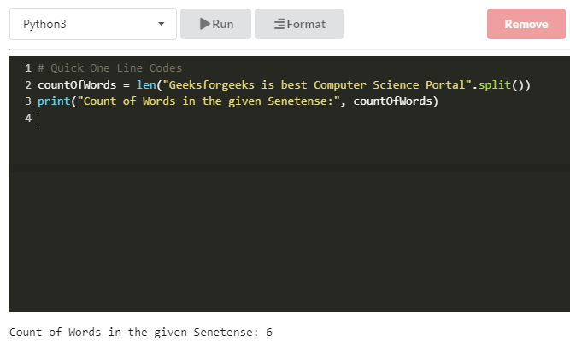

**Using split()** split function is quite useful and usually quite generic method to get words out of the list, but this approach fails once we introduce special characters in the list.